Ranskill School Uniform
Ranskill uniform is available from Uniform Direct.
There is a shop in Gainsborough (9 Market Street, Gainsborough. DN21 2BL) or you can order online.
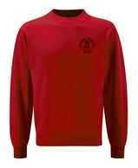 | 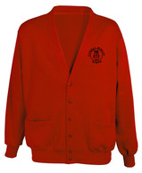 | 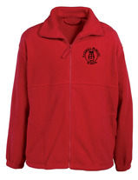
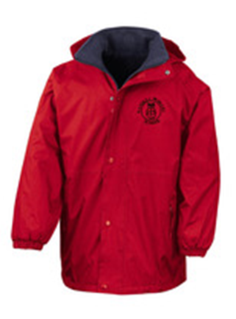 | 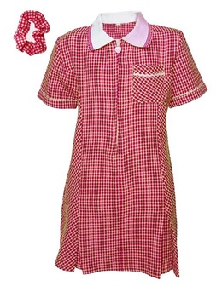 | 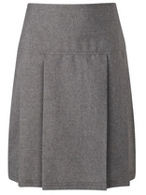
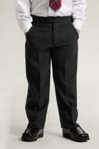 | 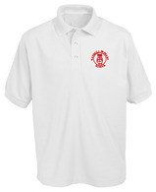 | 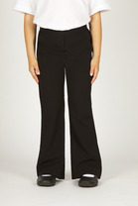
PE Kit in a draw string bag.
If sewing is not your thing these are widely available from ebay for as little as £2.00
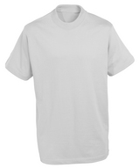 | 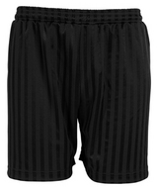 | 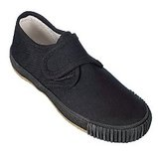
PLEASE name all uniform including the children’s shoes there are a variety of sew on, iron on or permanent markers available for this purpose.

