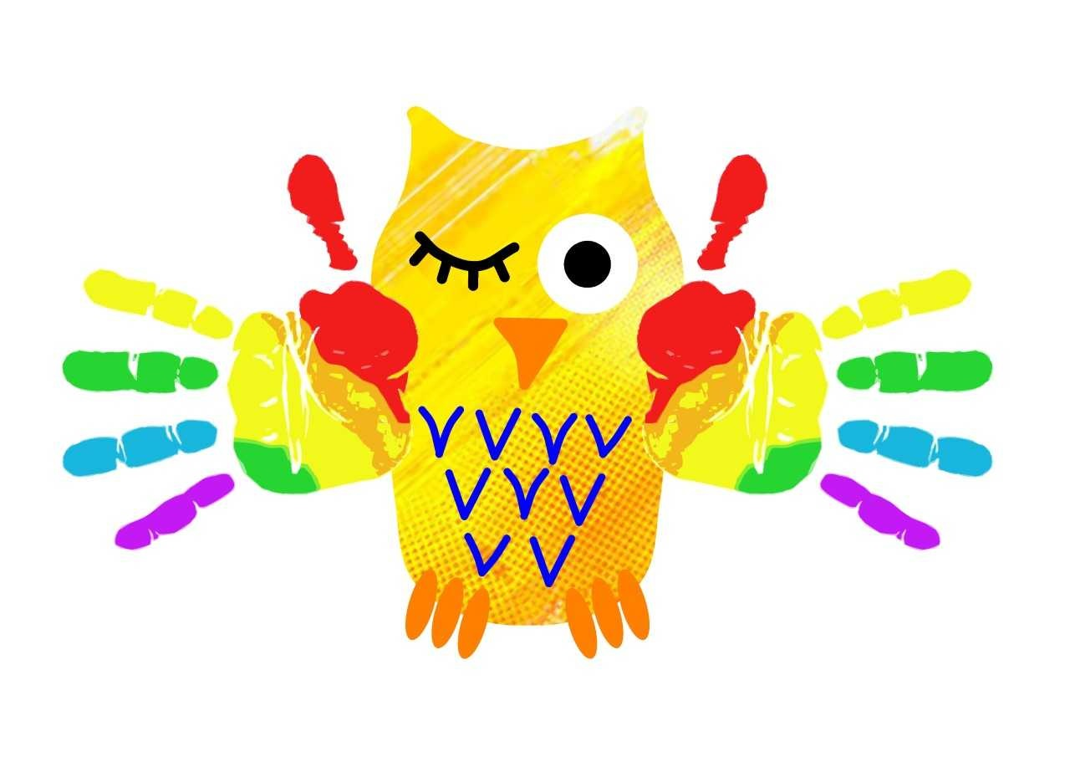

Dear Parent and Carers of Year 5 children,
Next year we are looking at having our traditional leavers’ hoodie as part of the Year 6 school uniform. We hope that this will give the children a sense of pride in being Year 6, as well as parents getting value for money out of the hoodie (which usually children can only wear at the very end of term). Obviously, this will mean that all of the hoodies will be red to match in with the rest of our uniform. Only first names will be added to the back of the design (it will say 21 rather than 20). If you do not want to wear a hoodie, all other usual school uniform can still be worn.
We have found a company which offers excellent value for money, whilst being of good quality (the school badge will be embroidered for example); however, we will need to order at least 20 hoodies in order to qualify for the £13.25 price.
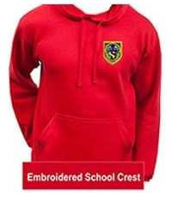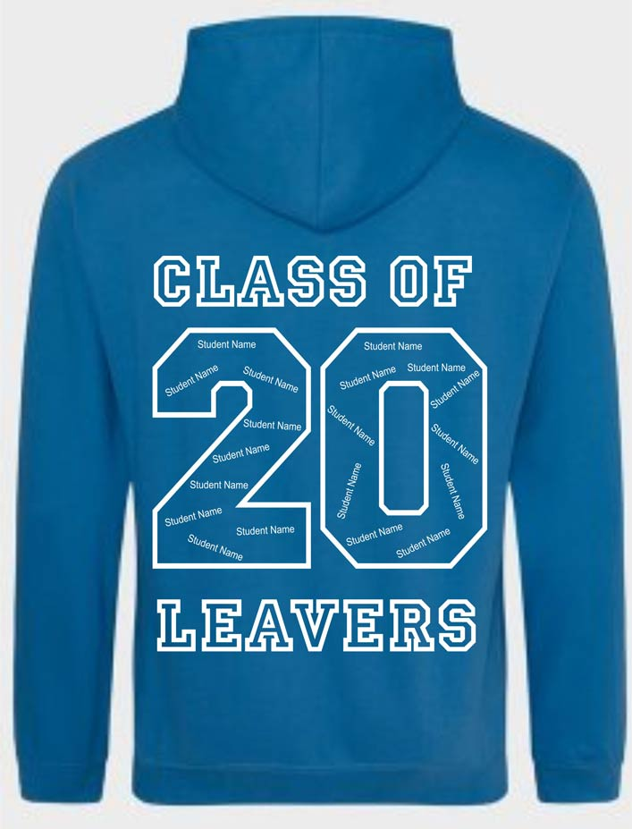
Please could you complete the order form attached separately to the email and email it back to school (or drop it in to the office) by July 1. We can then get the order off so the hoodies will definitely be here before September.
Please do get in touch if you have any further questions.
Yours,
Mrs Throssell






